

**Year 12 Human Biology**

**Inquiry Assessment: Human Evolution**

|  |
| --- |
| Name: |
| Teacher: |

|  |  |  |  |
| --- | --- | --- | --- |
|  | Marks Received | Marks Available | Percentage |
| Total |  | 35 |  |

Weighting: 5%

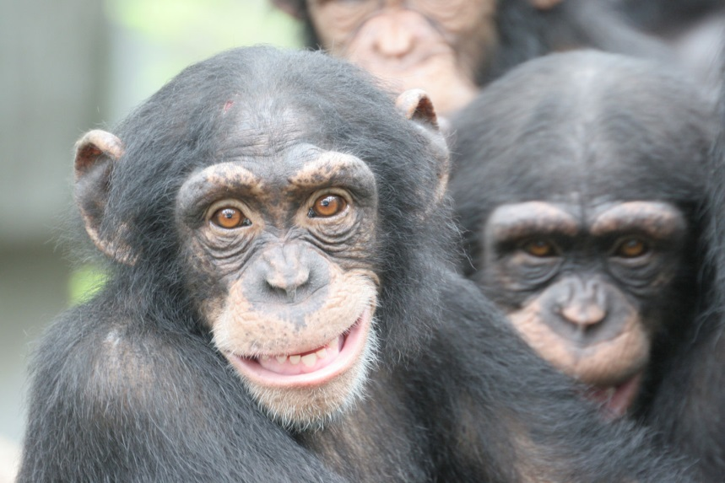

|  |  |  |
| --- | --- | --- |
| Hominin Species | Years Ago (MYA) | Average Brain Volume (cm3) |
| *Australopithecus afarensis* | 3.5 | 440 |
| *Australopithecus africanus* | 2.5 | 450 |
| *Paranthropus robustus* | 2.0 | 520 |
| *Homo habilis* | 1.8 | 575 |
| *Homo erectus* | 0.5 | 1100 |
| *Homo neanderthalensis* | 0.05 | 1550 |
| *Homo floresiensis* | 0.095 | 380 |
| *Homo sapiens* | 0.08 | 1450 |

**Table 1:** Changes in Hominin brain volume over time

1. Plot the data from Table 1 onto the graph paper below. (5 marks)

**Graph 1:**



Below there a three graphs. One compares the growth in brain size of humans and chimpanzees, the other compares brain size and body height in the Hominin species and the last compares the relative size of brains in a variety of mammals. Use these graphs as well as the graph you have created above to answer the following questions.

**Graph 2: Graph 3:**



**Graph 4:**

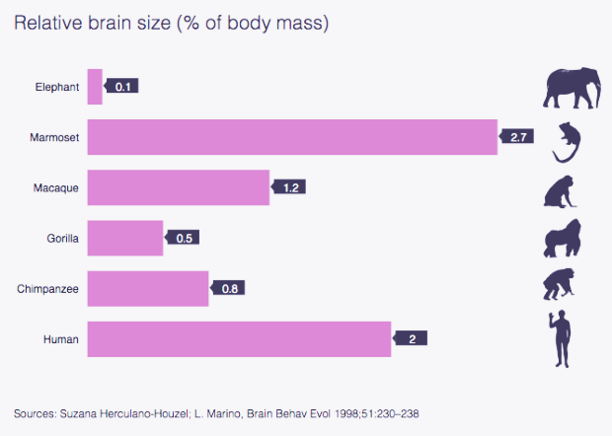

1. Describe the evolutionary trend that Graph 1 illustrates. (2 marks)

|  |
| --- |
| • More recently evolved species have larger brain volume (1 mark) |
| • Outlier – *Homo floresiensis* (1 mark) |
| • Exponentially increases |

1. Comment on the significance of brain/body size growth curve in humans compared to chimpanzees. Explain a potential reason for this difference.

(4 marks)

|  |
| --- |
| • Humans – growth of the brain continues at a high rate for the first five years of life (1 mark) |
| • Chimps – growth of the brain is at a high rate for the first two years of life (1 mark) |
| • Human are more dependent on parents in the first five years of life (1mark) |
| • Chimps reach independence much earlier than humans (1 mark) |
|  |

4a. Explain the significance of the shapes in Graph 3 to compare *H. sapiens and Australopithecines*. (5 marks)

|  |
| --- |
| • Shapes show the range of possible heights and brain volumes for each species (1 mark) |
| • Height:  - *H. sapiens* have a taller average height than *Australopithecines* (1 mark)  - Similar size ranges for height (1 mark) |
| • Brain volume:   * *H. sapiens*  have a larger average brain volume than *Australopithecines* (1 mark) * *H. sapiens*  have a much larger range than *Australopithecines* (1 mark) |

4b. Describe the overall patterns and trends present in Graph 3.

(3 marks)

|  |
| --- |
| • As height increases, brain volume increases (1mark) |
| • As height increases, the range increases (1 mark) for possible brain volumes (1 mark) |

5a. With respect to stature (body size) and brain size, comment on the position of *Homo floresienis* with respect to other hominins.

(2 marks)

|  |
| --- |
| • Smallest body size and brain volume compared to other Hominins (1 mark) |
| • Smallest range for brain volume and body size (1 mark) |

5b. Comment on the significance of the tools discovered in the Flores find mention below graph 3.

(2 marks)

|  |
| --- |
| • Advanced stone tools found with fossilised *H. floresiensis* remains |
| • Suggests that brain volume may not be the best indicator of intelligence (1 mark) |

1. Two parts of the brain; Broca’s area and Wernicke’s area have become highly developed in humans compared to other Hominins. Describe a likely selection pressure that resulted in these changes and how it would provide a survival advantage. (3 marks)

|  |
| --- |
| • Selection pressure is for language ability (1 mark) |
| • As these two parts of the brain are associated with speech (1 mark) |
| • Survival ability: improved communication skills are advantageous when hunting / evading predators / designing shelters or tools (1 mark) |

1. Name one variable which would influence the average brain volumes mentioned for species in Table 1. Explain your choice.

(2 marks)

|  |
| --- |
| • Age of individual |
| • Young children would have smaller brains than adults (as shown in graph 3) |

1. Predict the expected brain volume for a Hominin species that evolved 1 million years ago. (1 mark)

|  |
| --- |
| 800 – 900 cm3  (must have units) |

1. Use data to explain whether relative size of the brain is indicative of intelligence. (3 marks)

|  |
| --- |
| • No it is not indicative of intelligence (1 mark) |
| •The marmoset has the largest relative brain size of all species with it occupying 2.7% of its body mass (1 mark) |
| • But it is not considered to be more intelligent than humans (who have a smaller relative brain size of 2% of its body mass) (1 mark)  ***Must include data to get the third mark.*** |

1. Construct a table in the space below from the data in Graph 4. (2 marks)

|  |  |
| --- | --- |
| Species | Relative Brain Size (as a % of body mass) |
| Elephant  Marmoset  Macaque  Gorilla  Chimpanzee  Human | 0.1  2.7  1.2  0.5  0.8  2.0 |

Species on left hand side and relative brain size on right hand side (1 mark)

Data correctly transferred (1 mark)

1. Out of the species mentioned in the table above, which would you expect to physically have the largest brain. (1 mark)

|  |
| --- |
| Elephant |